**FULL STACK-PROJECT (2020-2021)**

**Health and Fitness website**

**(Web Development)**

**PROJECT REPORT**

**Department of Computer Engineering & Applications**

Institute of Engineering & Technology



**Submitted by** :- **Submitted to** :-

Anubhav Tomar (181500112) Mr. Pankaj Kapoor

Lokesh Yadav (181500351)

Mridul Srivastav(181500395)

Alok Kumar Upadhyay (181500068)

|  |
| --- |
| **TABLE OF CONTENTS** |
| **Certificate 4**  **Synopsis 5**  **Acknowledgement 7**  **Abstract… 8** |
| **1. Introduction….…………………………………………………………….** |
| 1.1 Overview 9 |
| 1.2 Motivation 9 |
| 1.3 Problem Statement 10 |
| 1.4 Objective… 10 |
| **2. Software Requirement Analysis…………………………………………..** |
| 2.1 System Analysis 11 |
| 2.2 Role of System Analyst 11 |
| 2.2.1 Main roles of System Analyst 12 |
| 2.3 Users 12 |
| * 1. Methodology 12   2. Dependencies /External Systems 13 |
| 1. **Implementation details 18=** 2. **Contribution Summary 18** |

|  |
| --- |
| 1. **Project Work 25** 2. **Future Scope… 40** |
| **Reference 40** |

**Certificate**

This is to certify that Anubhav Tomar, Lokesh Yadav , Mridul Srivastav, Alok Kumar Upadhyay students of B.Tech (CSE) 3rd year has successfully Completed the FULL STACK project named Health and Fitness on Web Development under the Guidance of Mr. Pankaj kapoor During 2020-21.

**Signature:**

**Mr. Pankaj Kapoor**(Mentor)

E:\Gopal.JPG

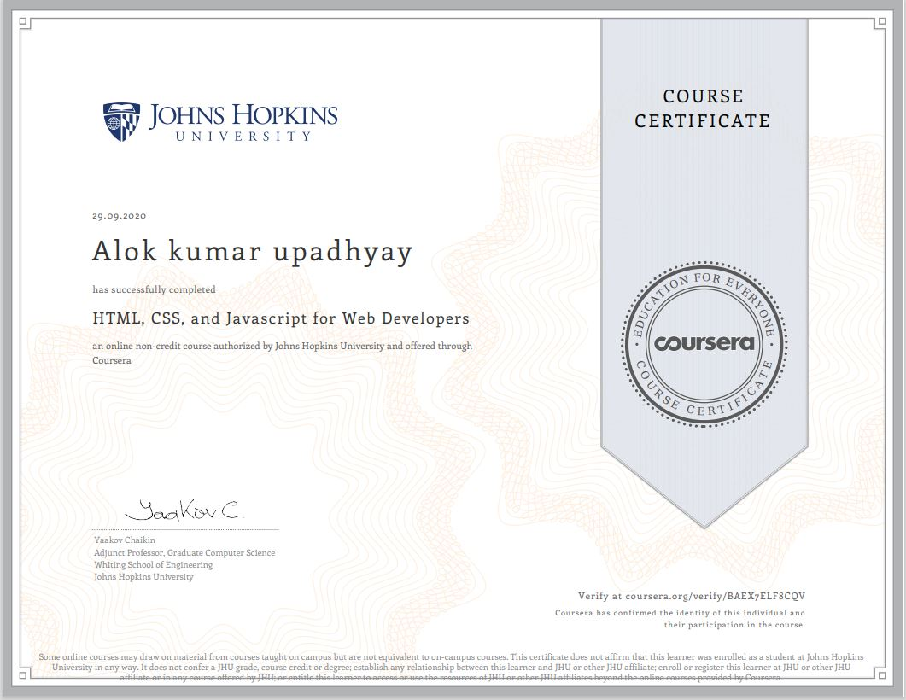E:\Kshitiz.JPG

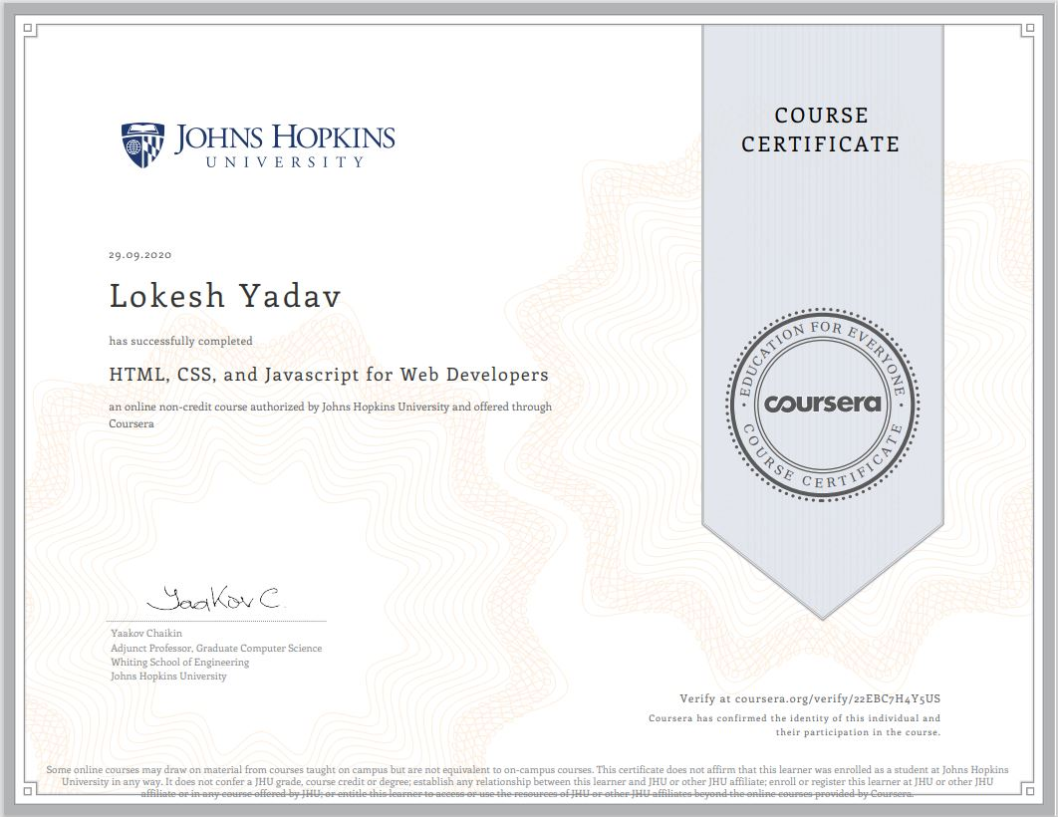



Project Information:

|  |  |
| --- | --- |
| Title Of Project/Training/Task | Health and fitness |
| Role & Responsibility | Anubhav Tomar :Front end  Lokesh Yadav : Front- end designer and documentation work  Alok Kumar Upadhyay : Front-End  Mridul Srivastav: documentation work |
| Technical Details | Hardware Requirements:   * Minimum Marshmallow version 7.0 ( for android ) * Pentium IV or higher, (PIV-300GHz recommended) * Hard-Disk 250GB or more * RAM 4GB or more * Processor i3 (7th Gen) * 1024 x 768 Display * Internet   Software Requirements:   * SYSTEM SOFTWARE :-   Operating System (Windows , Linux , MacOS )   * APPLICATION SOFTWARE :-   a) HTML  b) CSS  c) JavaScript  d) BootStrap  e) Github  f) Web Browser ( Google Chrome , Firefox , Safari , Mozilla , Internet Explorer ) |

**Summary of the Work:**

During the completion of this project Snakbok we learnt about HTML , CSS, JavaScript, BootStrap..

**Alok Kumar Upadhyay** implemented front-end and design the webpages.

**Lokesh Yadav**  implemented front-end part and designt the webpages.

**Anubhav Tomar** also helped in Front-end and completed modules according to the design given by **Alok Kumar Upadhyay** along with documentation work required doing the project building period.

**Mridul Srivastav** worked on front-end along with documentation work required doing the project building period.

Our mentor **Mr. Pankaj Kapoor** guided us and helped a lot whenever required by us.

**Acknowlegment**

We have taken efforts in this project. However, it would not have been possible without the kind support and help of many Teachers . I would like to extend my sincere thanks to all of them.

We are highly indebted to Mr. Pankaj Kapoor for her guidance and constant supervision as well as for providing necessary information regarding the project & also for his support in completing the project.

We would like to express my gratitude towards our parents & member of GLA University for their kind co-operation and encouragement which help us in completion of this project.

**Abstract**

The report presents the three tasks that is being in continuation which are listed below:

1. Understanding of the Problem objective & implication.
2. Understanding of the data & building of the model.
3. Evaluation of the model.

All these tasks have been completed successfully and results were according to expectations. All the tasks were need very systematic approach, starting from the collection of the data to the implementation of the solution and till evaluation of the System. The most challenging task was the domain knowledge, to understand the language. It is one of the major areas and really need very fundamental and conceptual knowledge of HTML, JS, CSS, BootStrap.

# Introduction

* 1. Overview
     + All the functional/non-functional requirements, Diagrams have been organized in this report. Along with these designs, this report also contain the essential data of this project.
     + The complete description of the application followed by the functionalities has been listed initially. Later on, the Webpage has been described diagrammatically with the help of different designing tools like Data Flow Diagram, Use Case Diagram, Interaction Diagram and E-R Diagram.
  2. Motivation

In today’s generation peoples are more depended on the internet for find the health related tips they often waste their time in searching. So they have to visit different websites for finding proper content to accomplish their needs. And we often find that some websites have some issue of provide solutions . Or maybe it’s difficult to get the proper tips with different problems .

So, we come up with this idea of making a webpage for helping such where they can find all the needed information at one place. This website is mainly for employees and it Provides tips peoples can easily get all the content of health in free of cost.

THE BASIC OBJECTIVE OF THIS PROJECT IS TO INCREASE health awareness by providing health screenings, activities, materials, demonstrations,and information.

* 1. Problem Statement

In today’s generation peoples are more depended on the internet to find most of the things. peoples often waste their time in searching healthy tips . so they have to visit different websites for finding proper tips and solutions to accomplish their needs.

So, we design a website which solves all these problems.

* 1. Objective

To provide physical activity that will enable each person to monitor desired gains.

To provide activities that relieve emotional strain and tension.

To provide a safe place where people are accepted no matter what their limitations might be

To develop skill, interest and the appreciation for the need of life

Improve your ability to think critically in the areas of personal wellness and

be able to make proper decisions regarding your overall health

Be able to take knowledge that is learned regarding wellness and use it to help others in society

To become motivated to take responsibility for oneself and make positive health behavior changes

Increase health awareness by providing health screenings, activities, materials, demonstrations, and information

To develop all aspects of oneself physical, social, mental

, spiritual

To develop a wellness awareness within our community

To develop a community network for wellness promotion

To give one a sense of purpose

To provide a support group

To teach self care practices

1. System and Requirement Analysis
   1. System Analysis

System analysis is a process of collecting and interpreting facts, identifying the problems, and decomposition of the system into its components.

It is a process of studying a system in order to define its goals or purposes and to discover operations and procedures for accomplishing them most efficiently.

Here the problem is people face a common problem of exposure. Most of the time, peoples often waste their time in searching health tips so they have to visit different websites for finding proper health related tips and solutions to accomplish their needs.

So, we design a website which solves all these problems.

Role of System Analyst

The system analyst is a person who is thoroughly aware of the system and guides the system development project by giving proper directions. He is an expert having technical and interpersonal skills to carry out development tasks

required at each phase.

* + 1. Main Roles of System Analyst:
       - Defining and understanding the requirement of user through various fact finding techniques.
       - Prioritizing the requirements by obtaining user consensus.
       - Maintains analysis and evaluation to arrive at appropriate system which is more user friendly.
       - Draw certain specifications which are easily understood by users and programmer in precise and detailed form.
       - Implement the logical design of system which must be modular.
  1. Users

The User of the web page would be the peoples (who have been signed up for the website ) and Admin of this portal only.

* 1. Methodology

Our methodology is designed to help you take maximum advantage of the internet technologies. It incorporate all aspects related to our website and allows us to ensure that the final product is of the highest standards. Below are the steps we will take to ensure that all your deliverables are completed in time .

Requirements analysis

The first step for us is to analyze your and your target`s requirements. Who will be visiting your website, what will be the purpose of their visit, what is the primary goal of your website, how can your organization best cater to their needs etc. Many such questions are analysed for the Needs Analysis stage.

If we are given access to the current website statistics, we would also like to analyze your current page views, average user time spent on the site, top landing pages, existing search engine rankings, existing bounce rates and many such factors. We analyze your online target audience and assess your differentiation strategy to best attract and retain your online visitors.

Your website will also undergo comprehensive search engine analysis twice during the course of the project; once during this stage and once again after the deployment (Go Live phase) of your website.

Website handover

Once the site is setup on your destination server, upon your approval we make the website live. One final set of testing is done on the live website for the quality assurance purposes. We then hand over the control of the site to you.

* 1. Dependencies/External Systems

User Interfaces:

UI-1: The Health and fitness webpage shall permit complete navigation; including all the functionalities described above, starting from a simple login or registration to access the company information , to go through the feedbacks given by old users ,users can give their suggestion to the admins and to give a quiz of several subjects . The portal is universally accessible on almost all PCs and smart phones.

Hardware Interfaces:

There are three external machines/devices used by the portal, each related to a user interface. These are a server machine at the admin end, hosting the portal, a PC at club’s end, keeping log of the registration and membership entries made to them & providing them with an interface to do their part of

functionality offered, last one is a PC or a smart phone at user’s end to access the portal. The devices at the user end behave as terminals and not for storing any type of data. Also capable of taking user input. All order and transaction should be stored on server.

HARDWARE REQUIREMENT (MINIMUM)

* 20 GB OF HARDDISK
* Processor i3 (7th Gen)
* 1024 x 768 Display
* Internet
* Minimum Marshmallow version 7.0 ( for android )
* Pentium IV or higher, (PIV-300GHz recommended)
* Hard-Disk 250GB or more
* RAM 4GB or more
* Processor i3 (7th Gen)

SOFTWARE REQUIREMENT-

* SYSTEM SOFTWARE
  + Operating System (Windows 7, Linux)
* APPLICATION SOFTWARE
  + - HTML ( front-end )
    - CSS
    - JavaScript
    - BootStrap
    - Github
* Web Browser :-
  + - Google Chrome , Firefox , Safari , Mozilla , Internet Explorer

1. Implementation Details

I am creating a website in which i am using HTML, CSS and other web development languages.

## Contribution Summary

OUR TEAM:

Mridul Srivastav: Front-end and Designer

Anubhav Tomar: Front-end and Designer

Lokesh Yadav : Front- end designer and documentation work

Alok Kumar Upadhyay : Front-End

.

**PROJECT WORK**

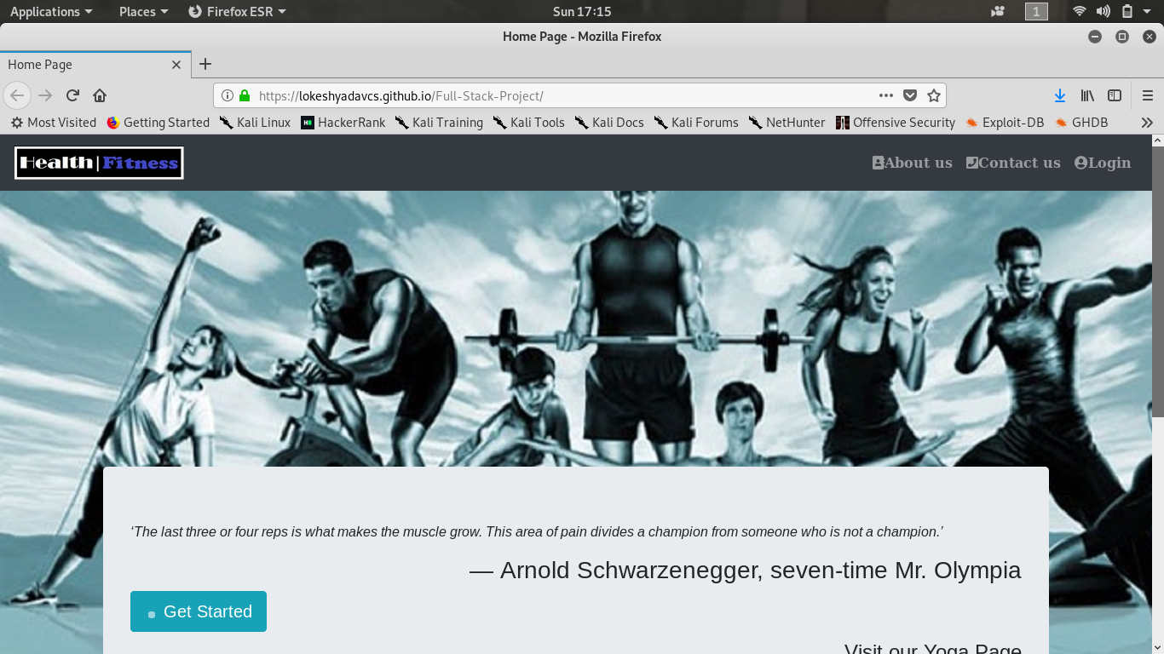

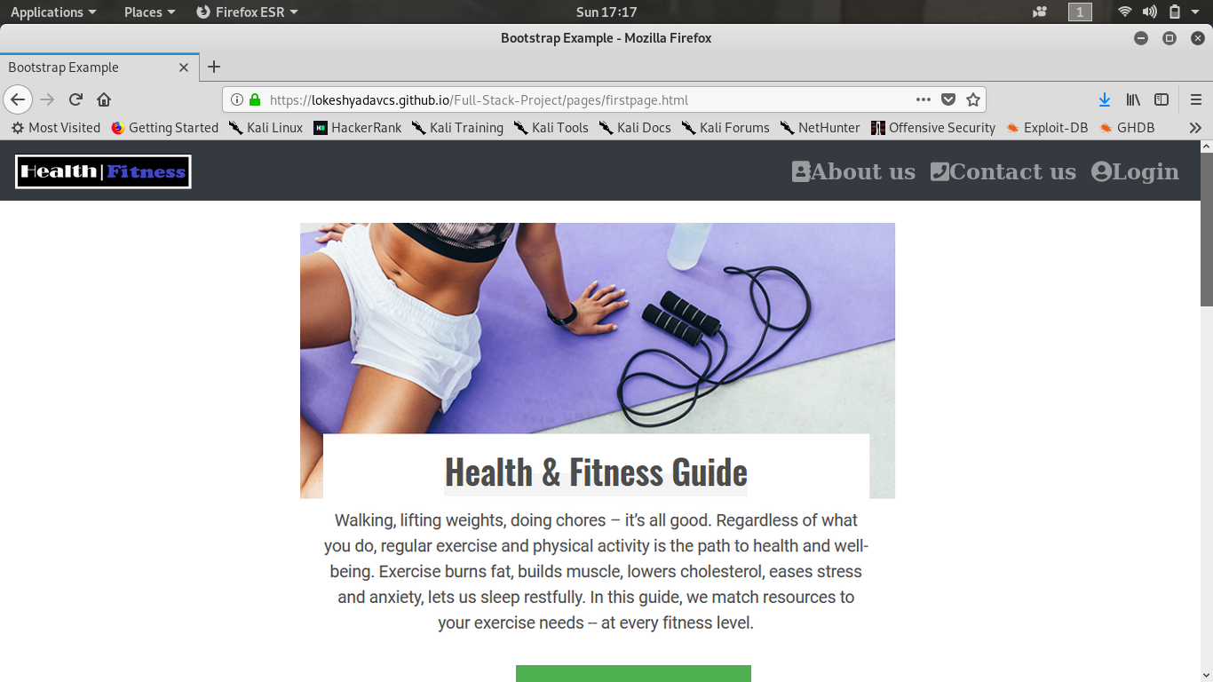

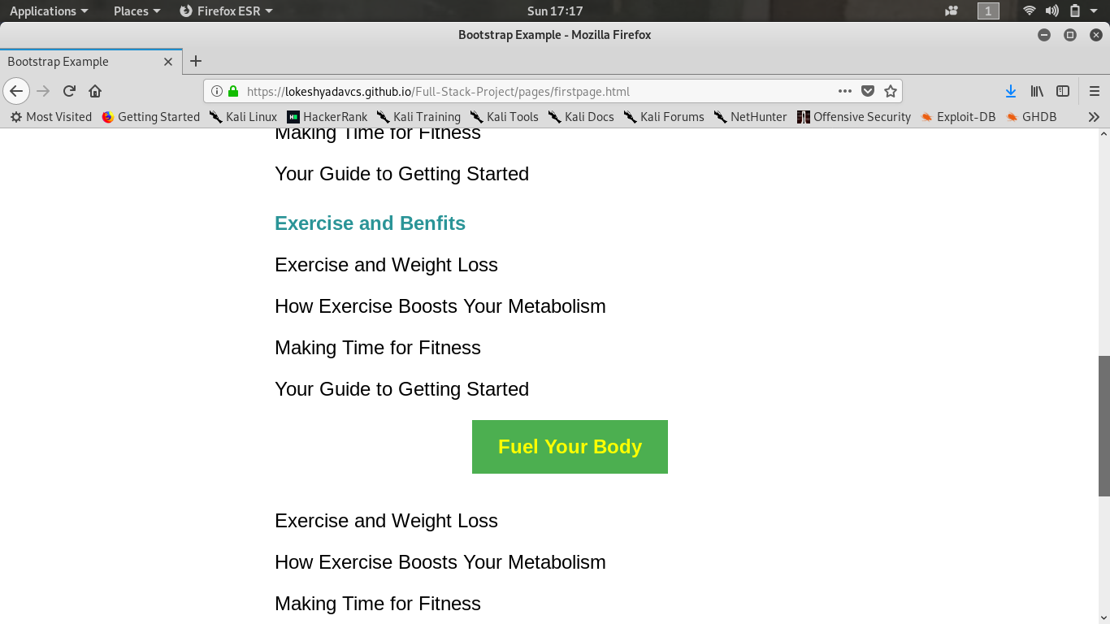

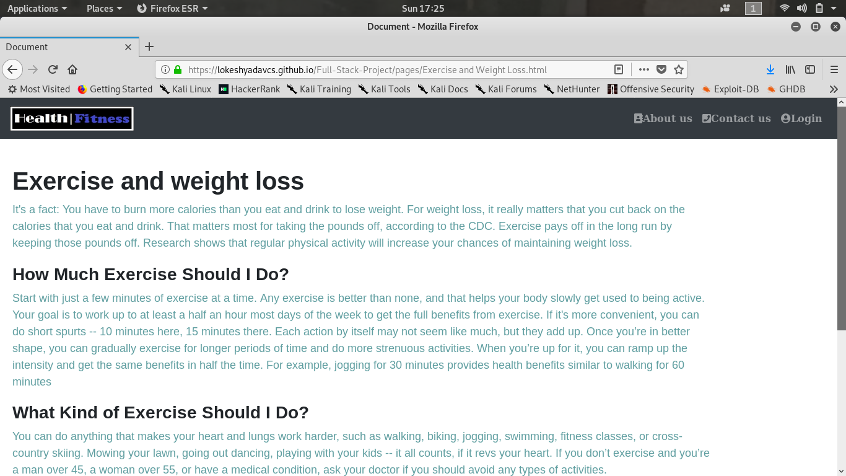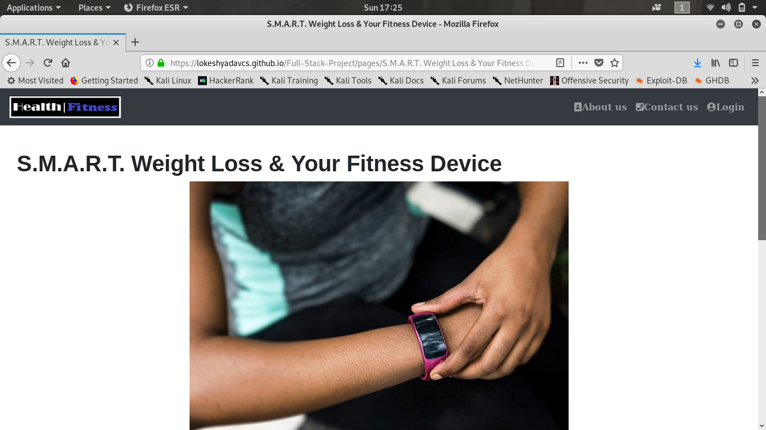

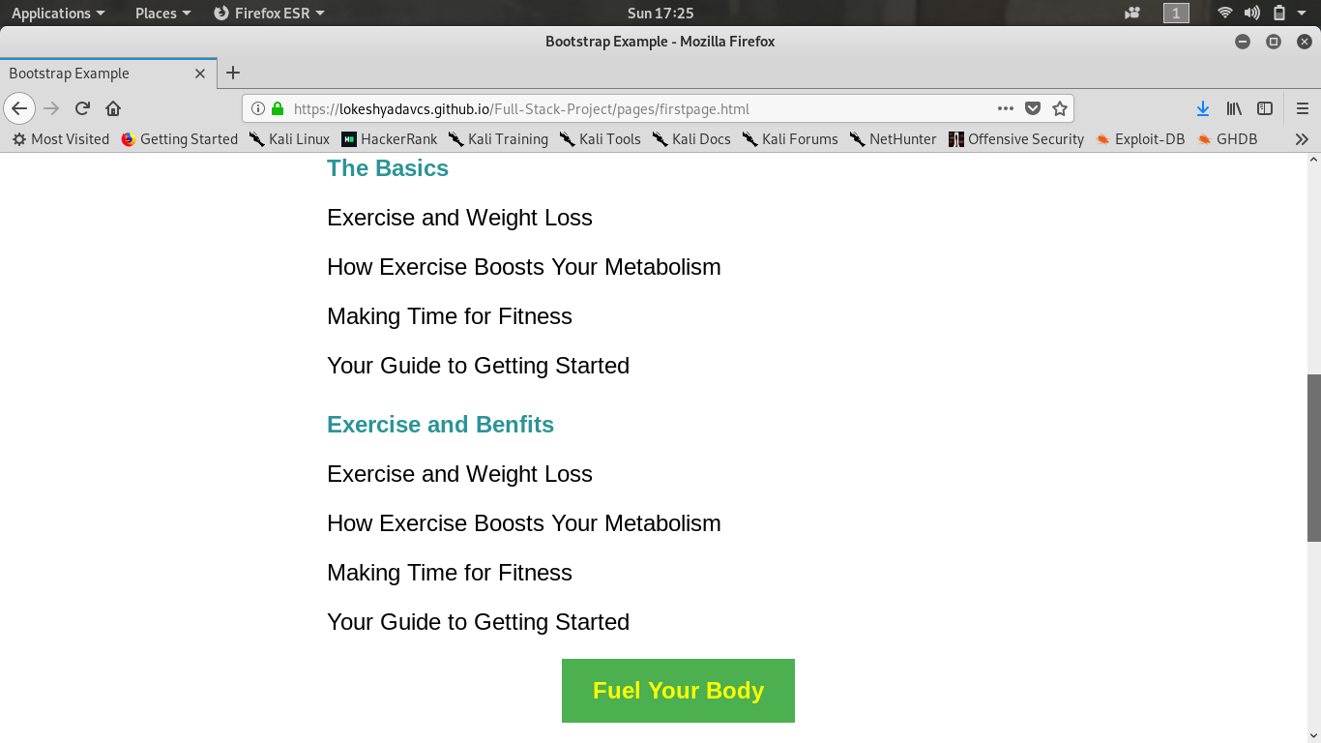

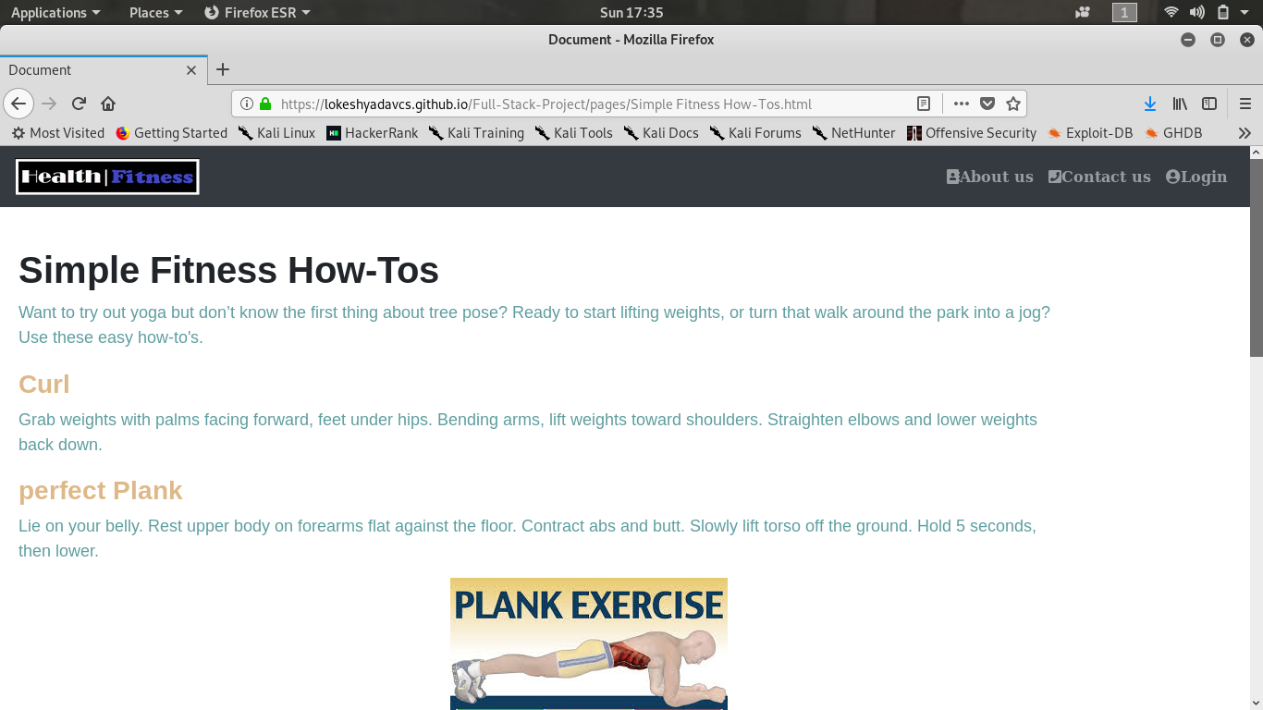

**Future Scope:**

Health and fitness is going to help the needy who wants to healthy tips. Not only it will save time but all the options available under single website will save lots of efforts for them.

This will help them a lot as many times we don’t get a source to get to know about this information.

**References:**

* [**www.javatpoint.com**](http://www.javatpoint.com/)
* [**www.w3school.com**](http://www.w3school.com/)
* [**www.tutorialspoint.com**](http://www.tutorialspoint.com/)
* [**www.youtube.com**](http://www.youtube.com/)
* **www.google.com**
* **Faculty Guideline:**
  + **Mr. Pankaj Kapoor**